

Assignment 4

INFO20172 IT Project Management using PMP

Class Id: 1255_1152

Group: 10

Students: Ronish Makaju, Subin Adhikari, Niranjan Bastakoti,Jay Nareshkumar Patel

Jira individual account site key: 152makajuronishmakaju

Gmail account used:ronishmakaju12345@gmail.com

Contents

Assign story points 2

Creating custom field 5

Relative Cost of Delay 8

Filters 11

Assign story points  
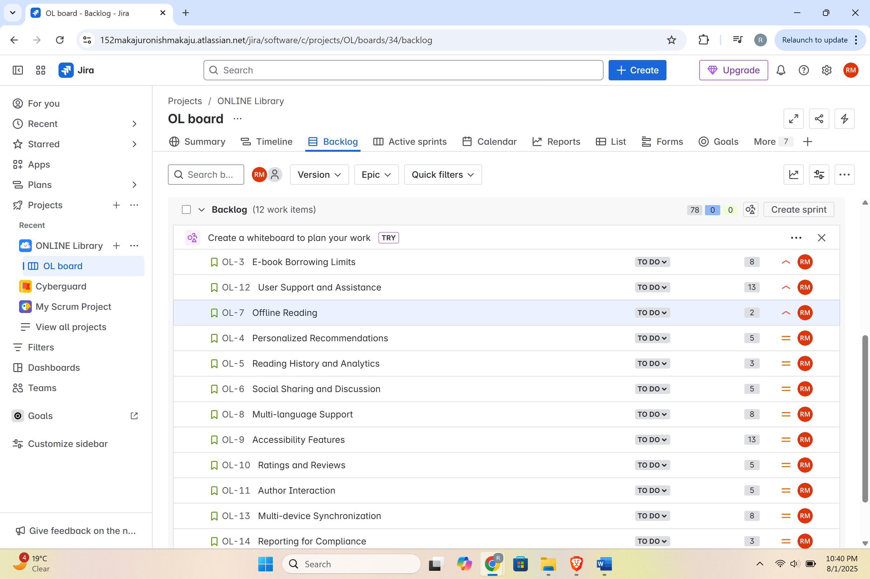  
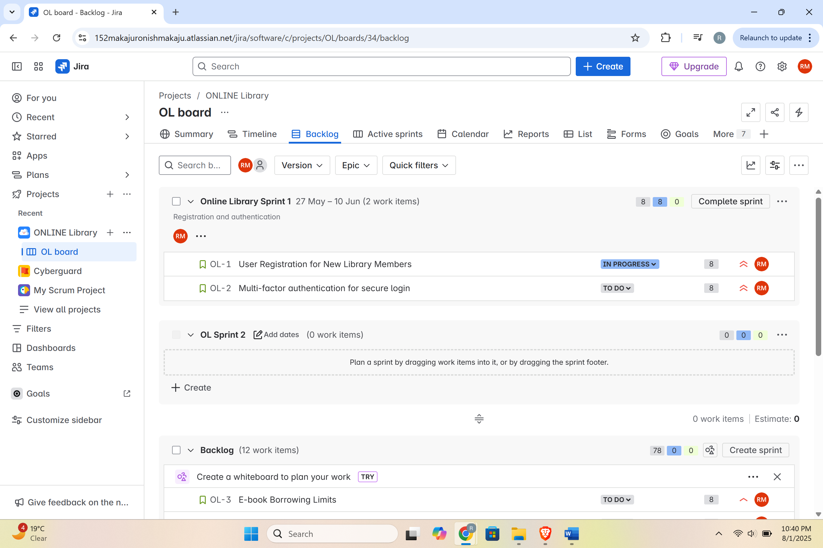

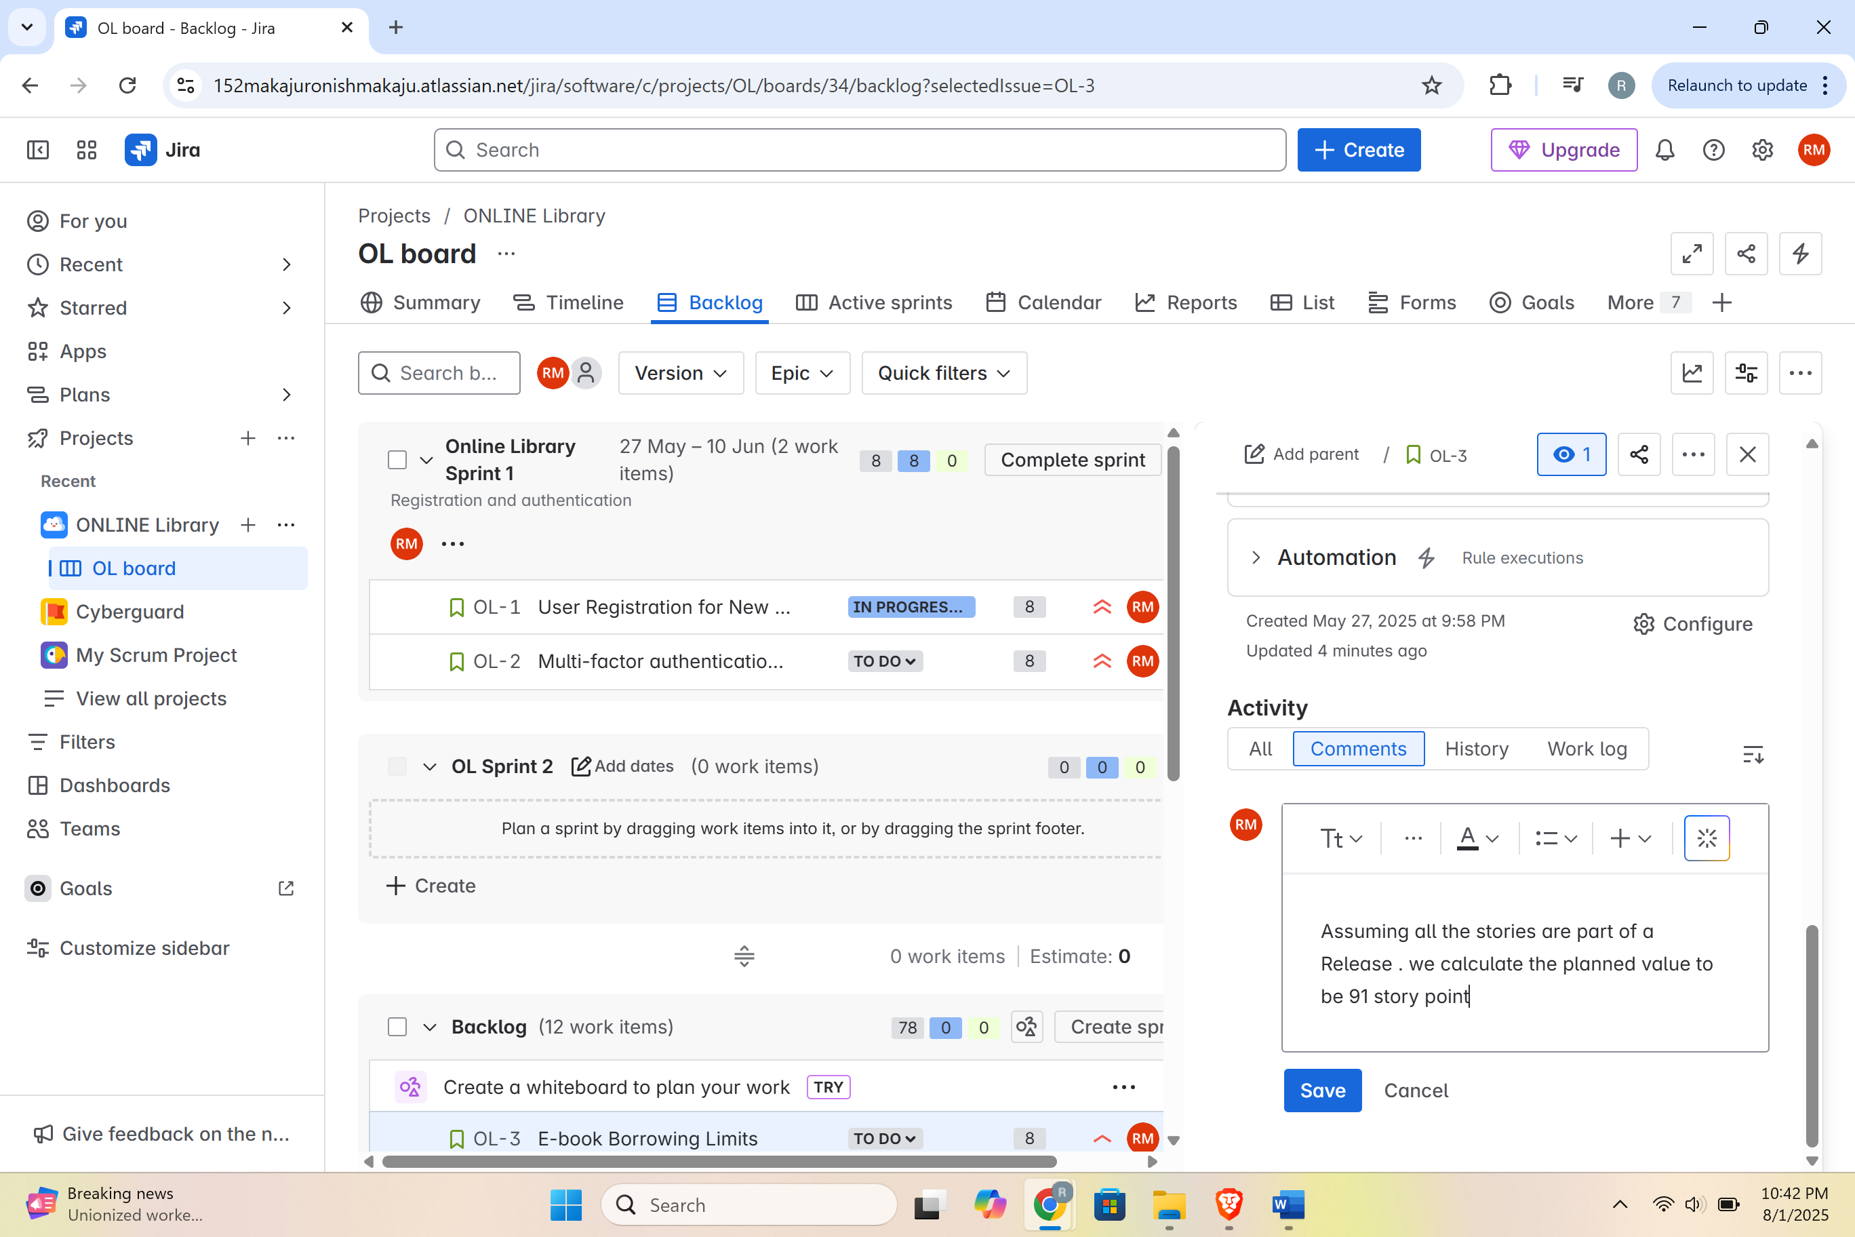

Creating custom field  
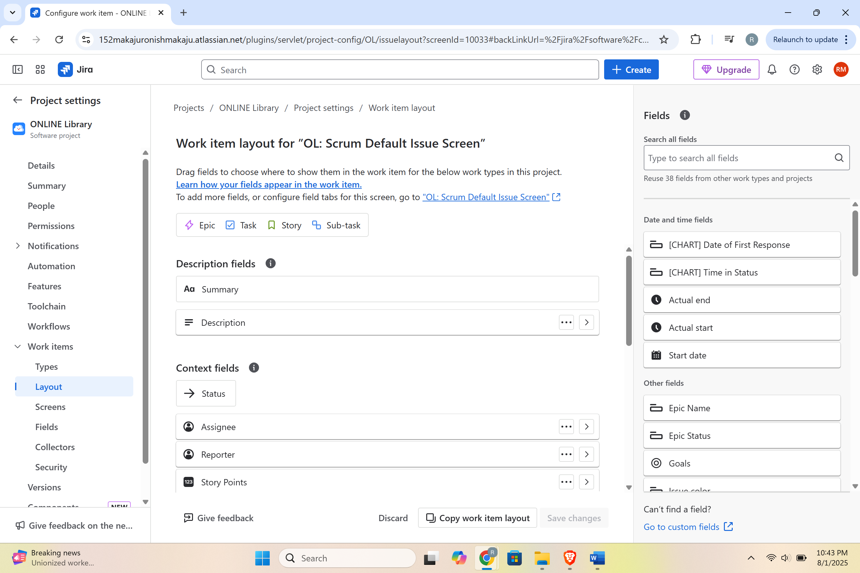  
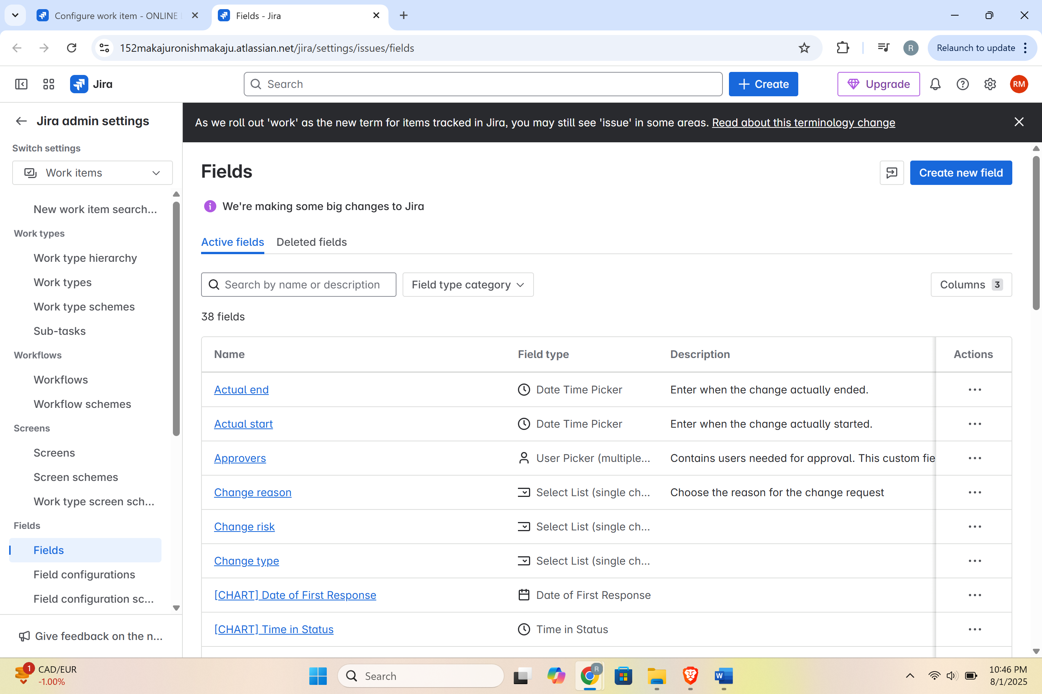  
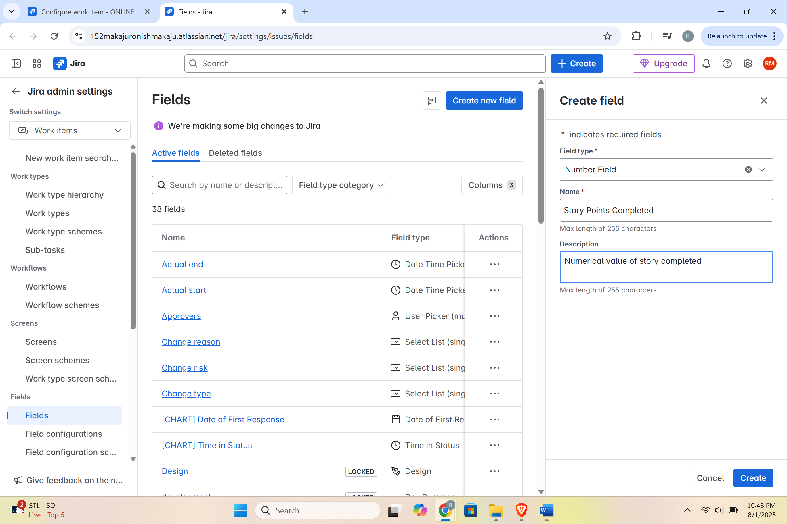 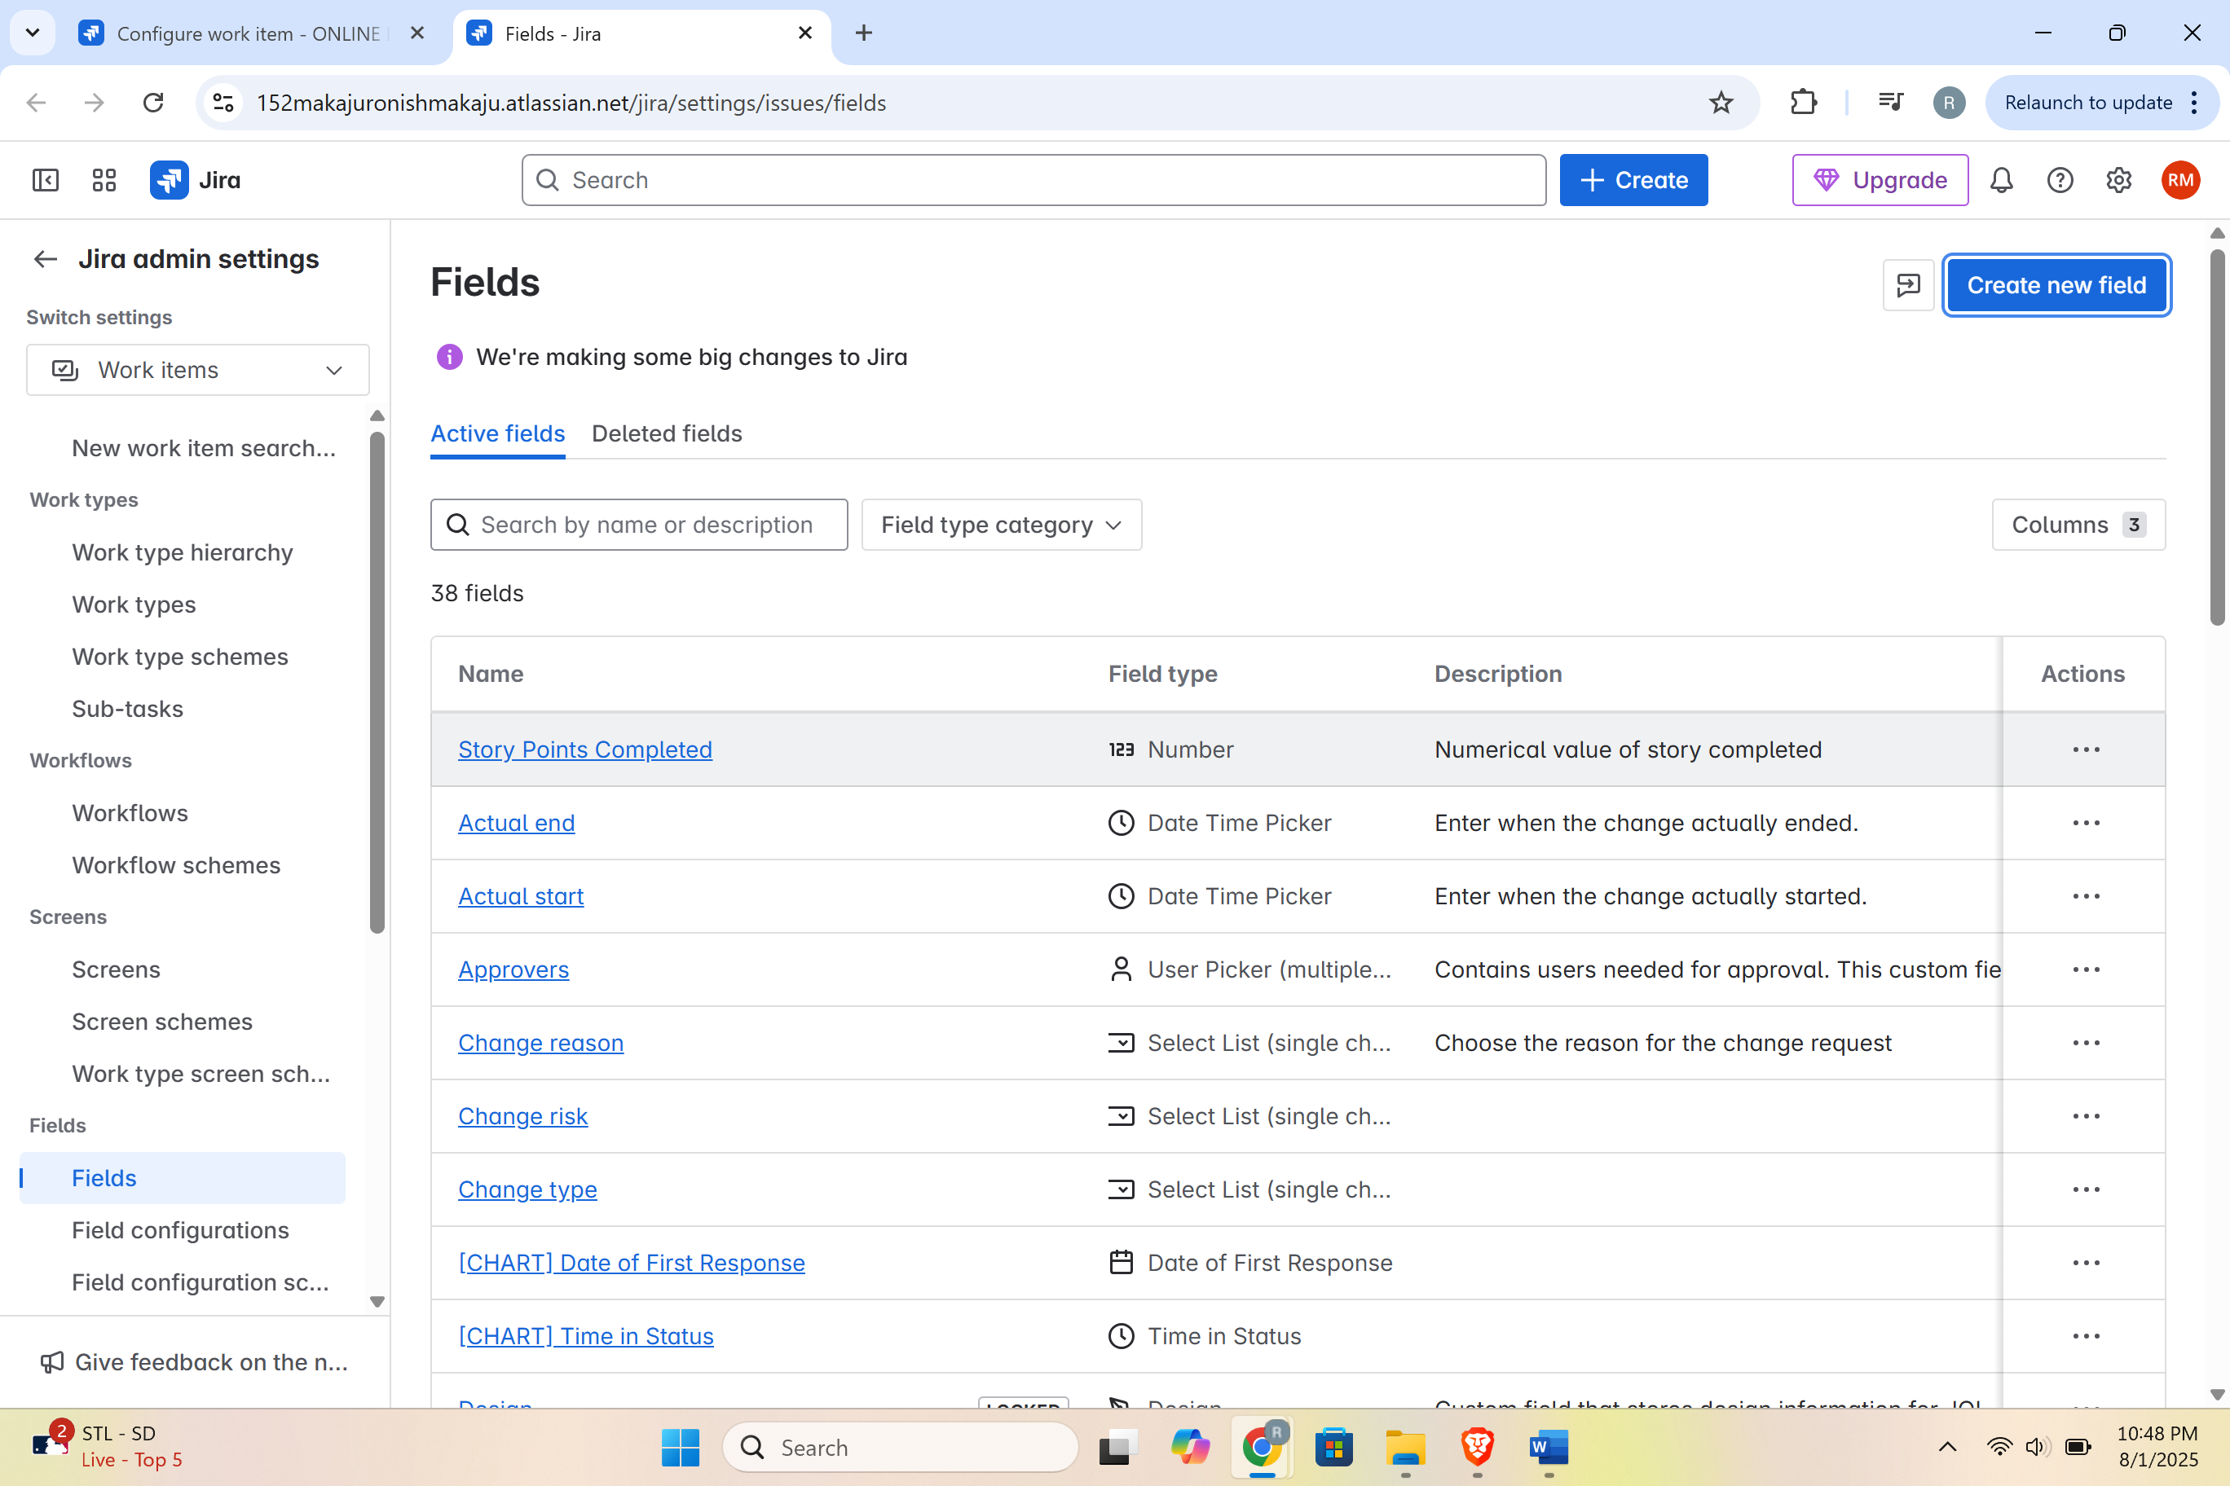 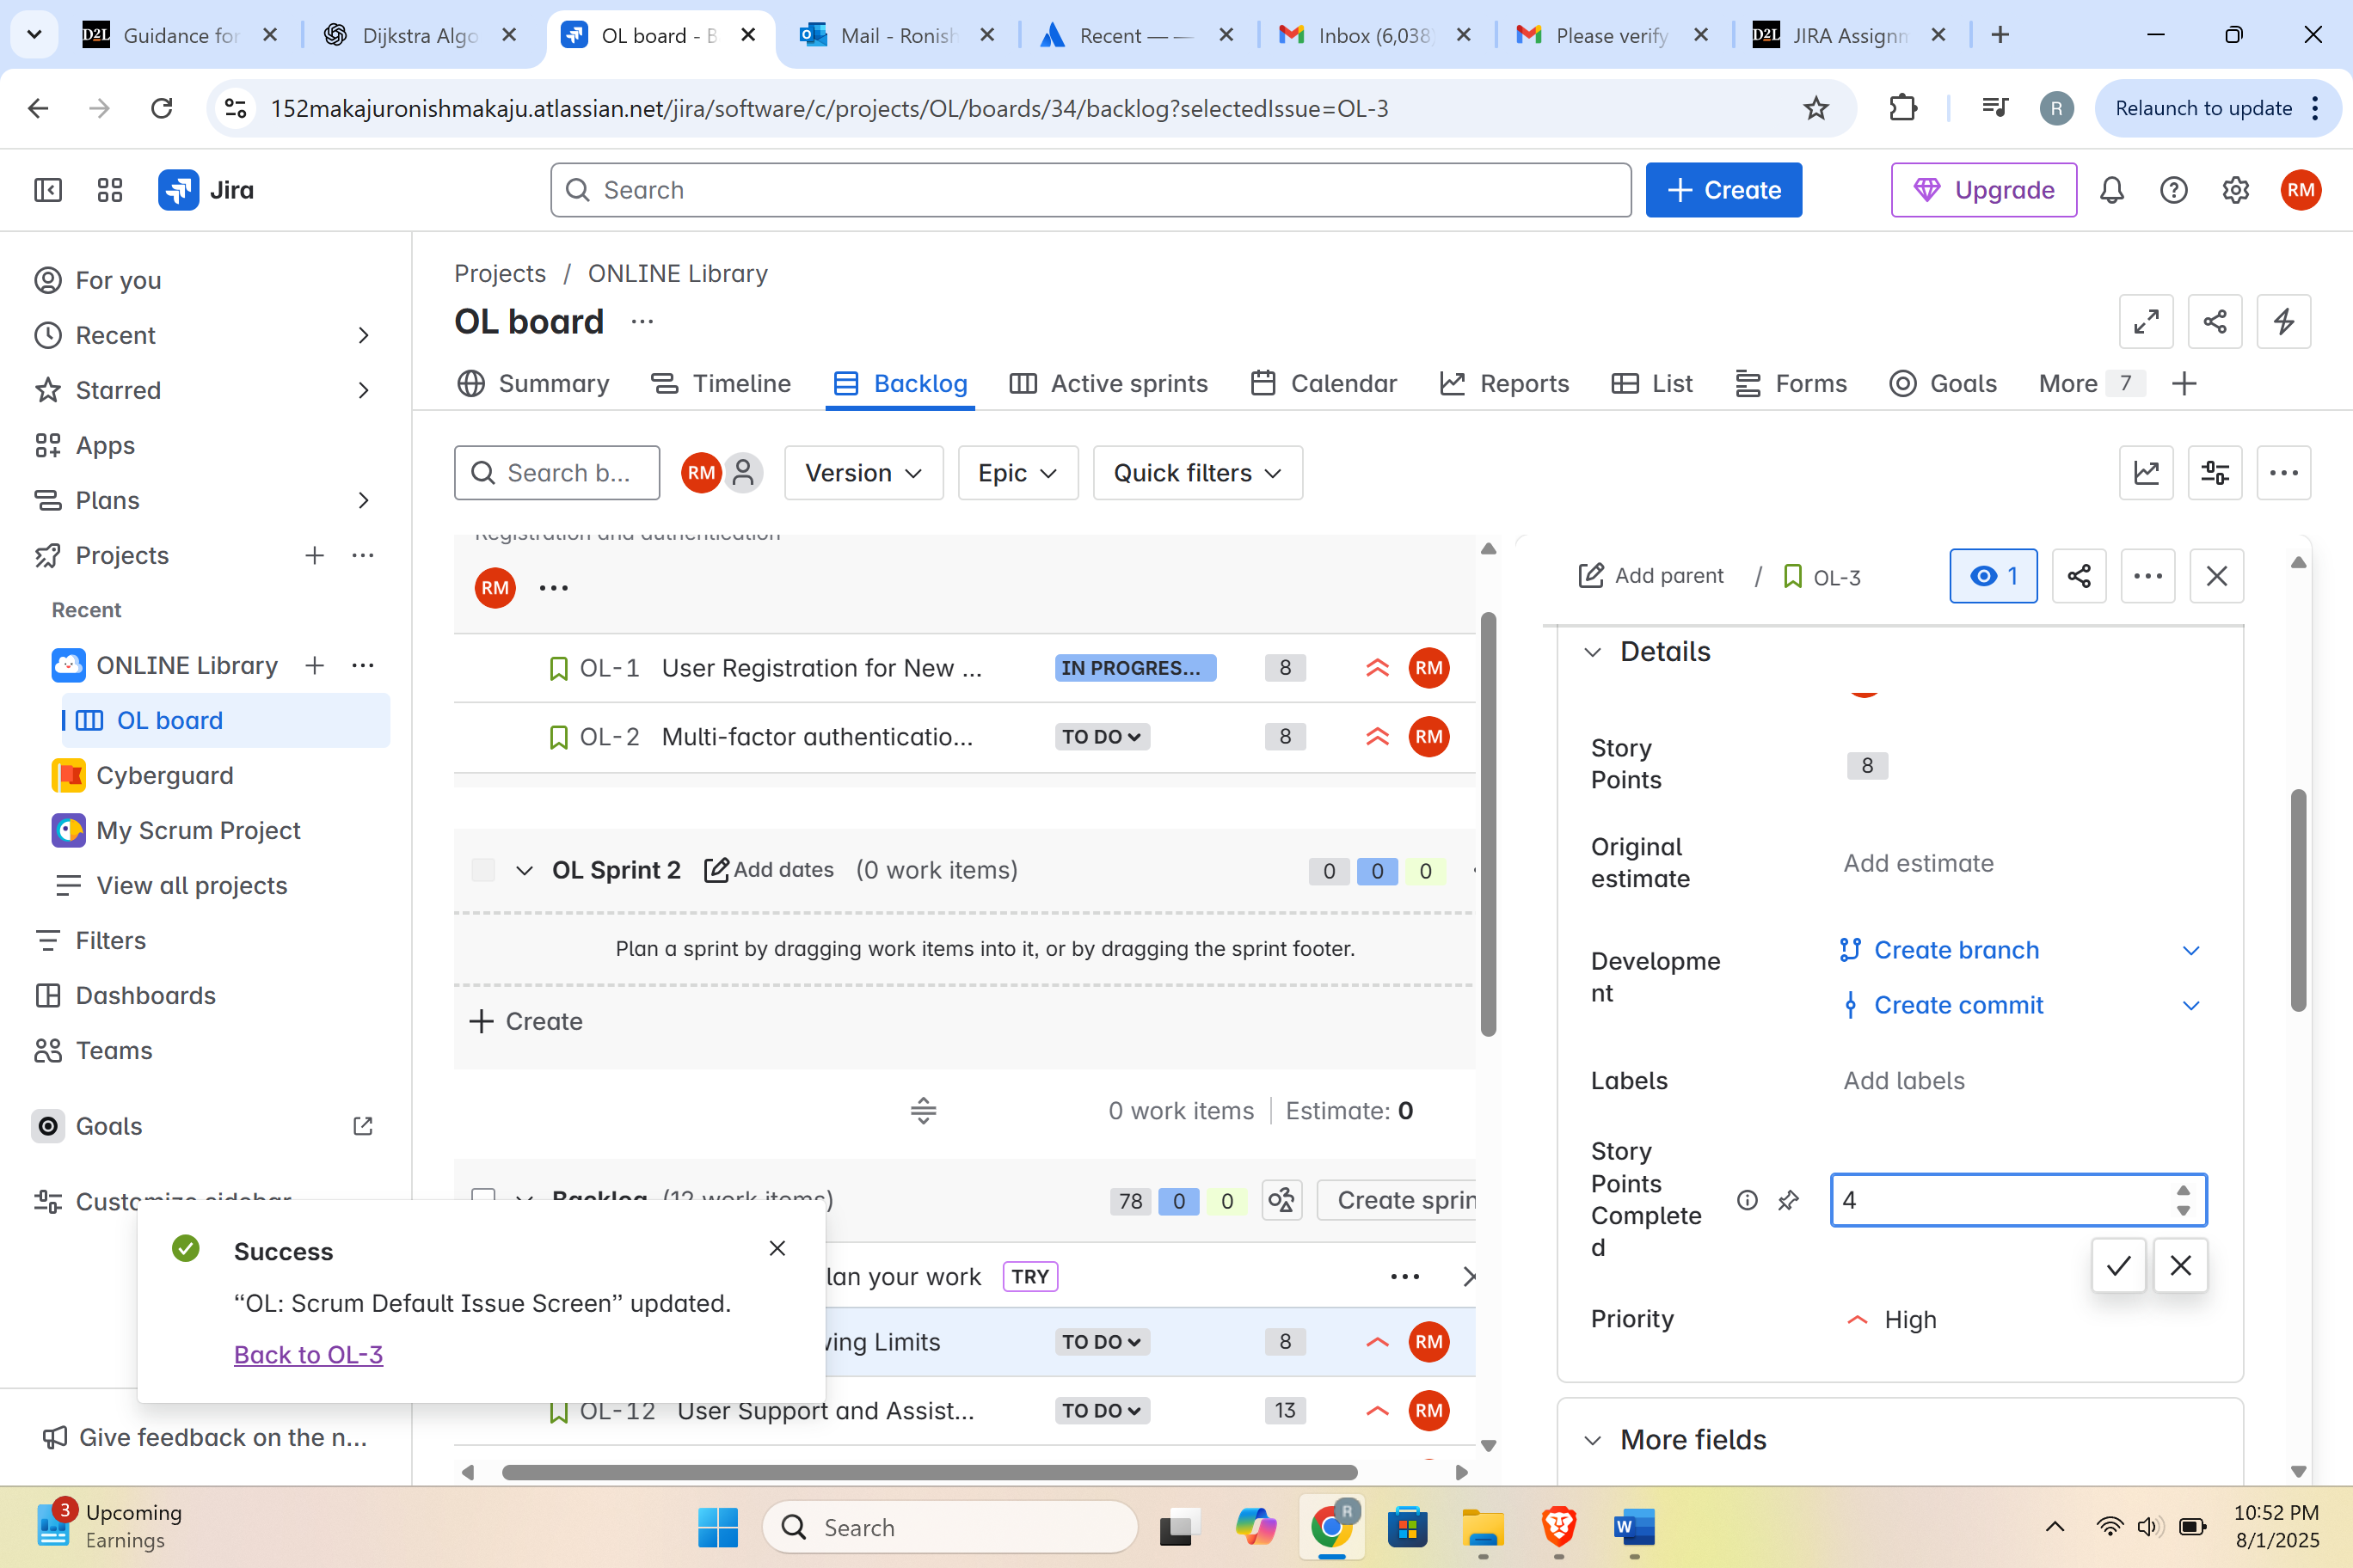

# Relative Cost of Delay

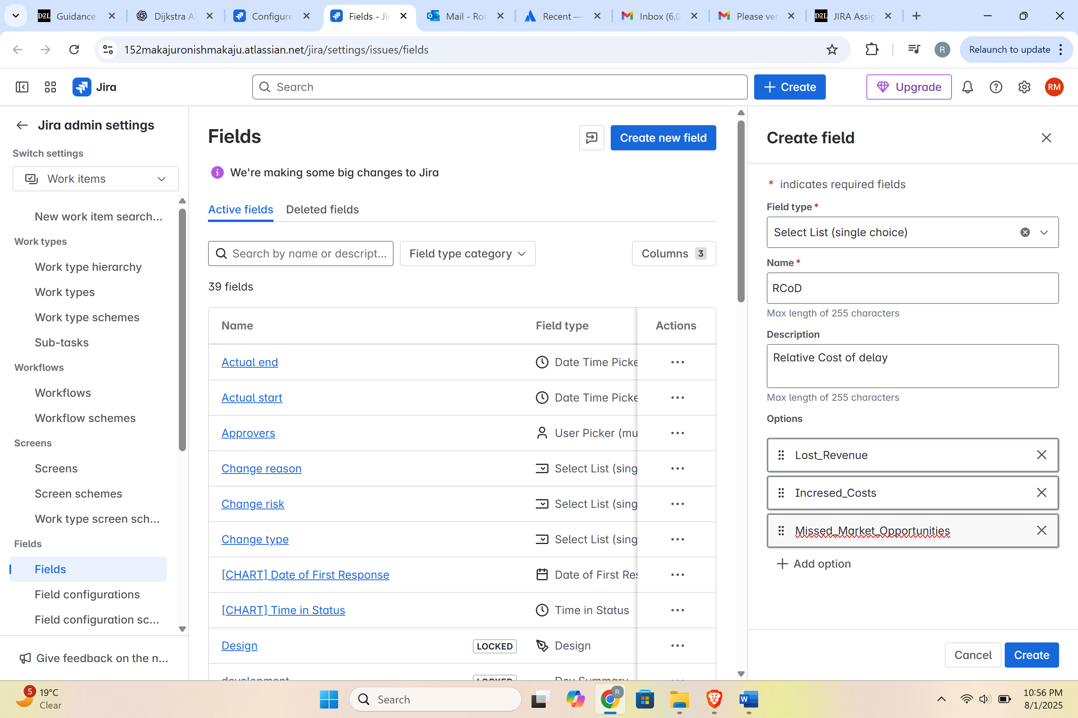

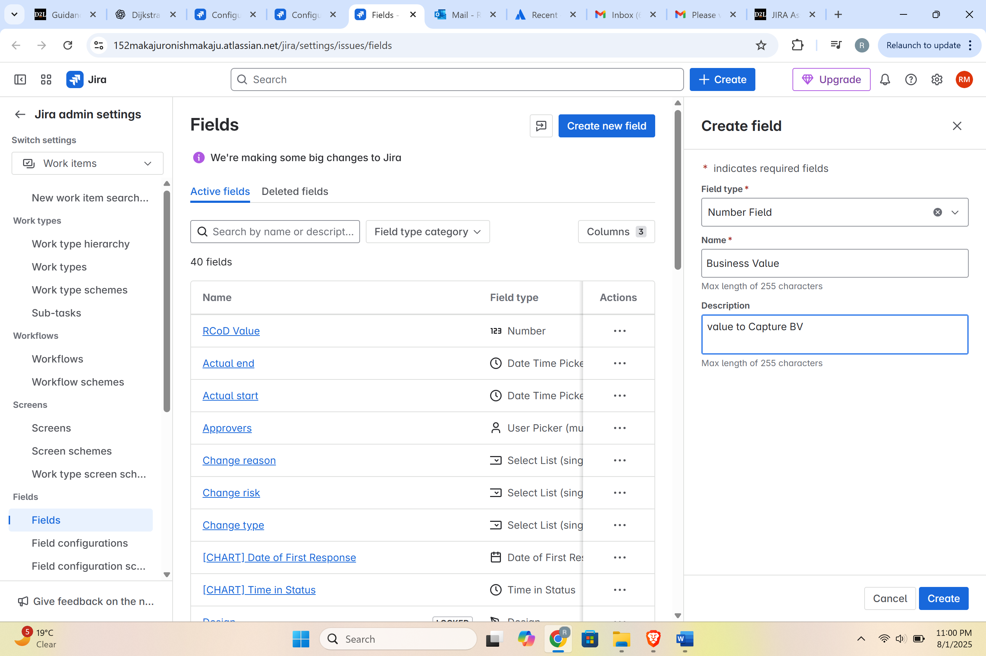

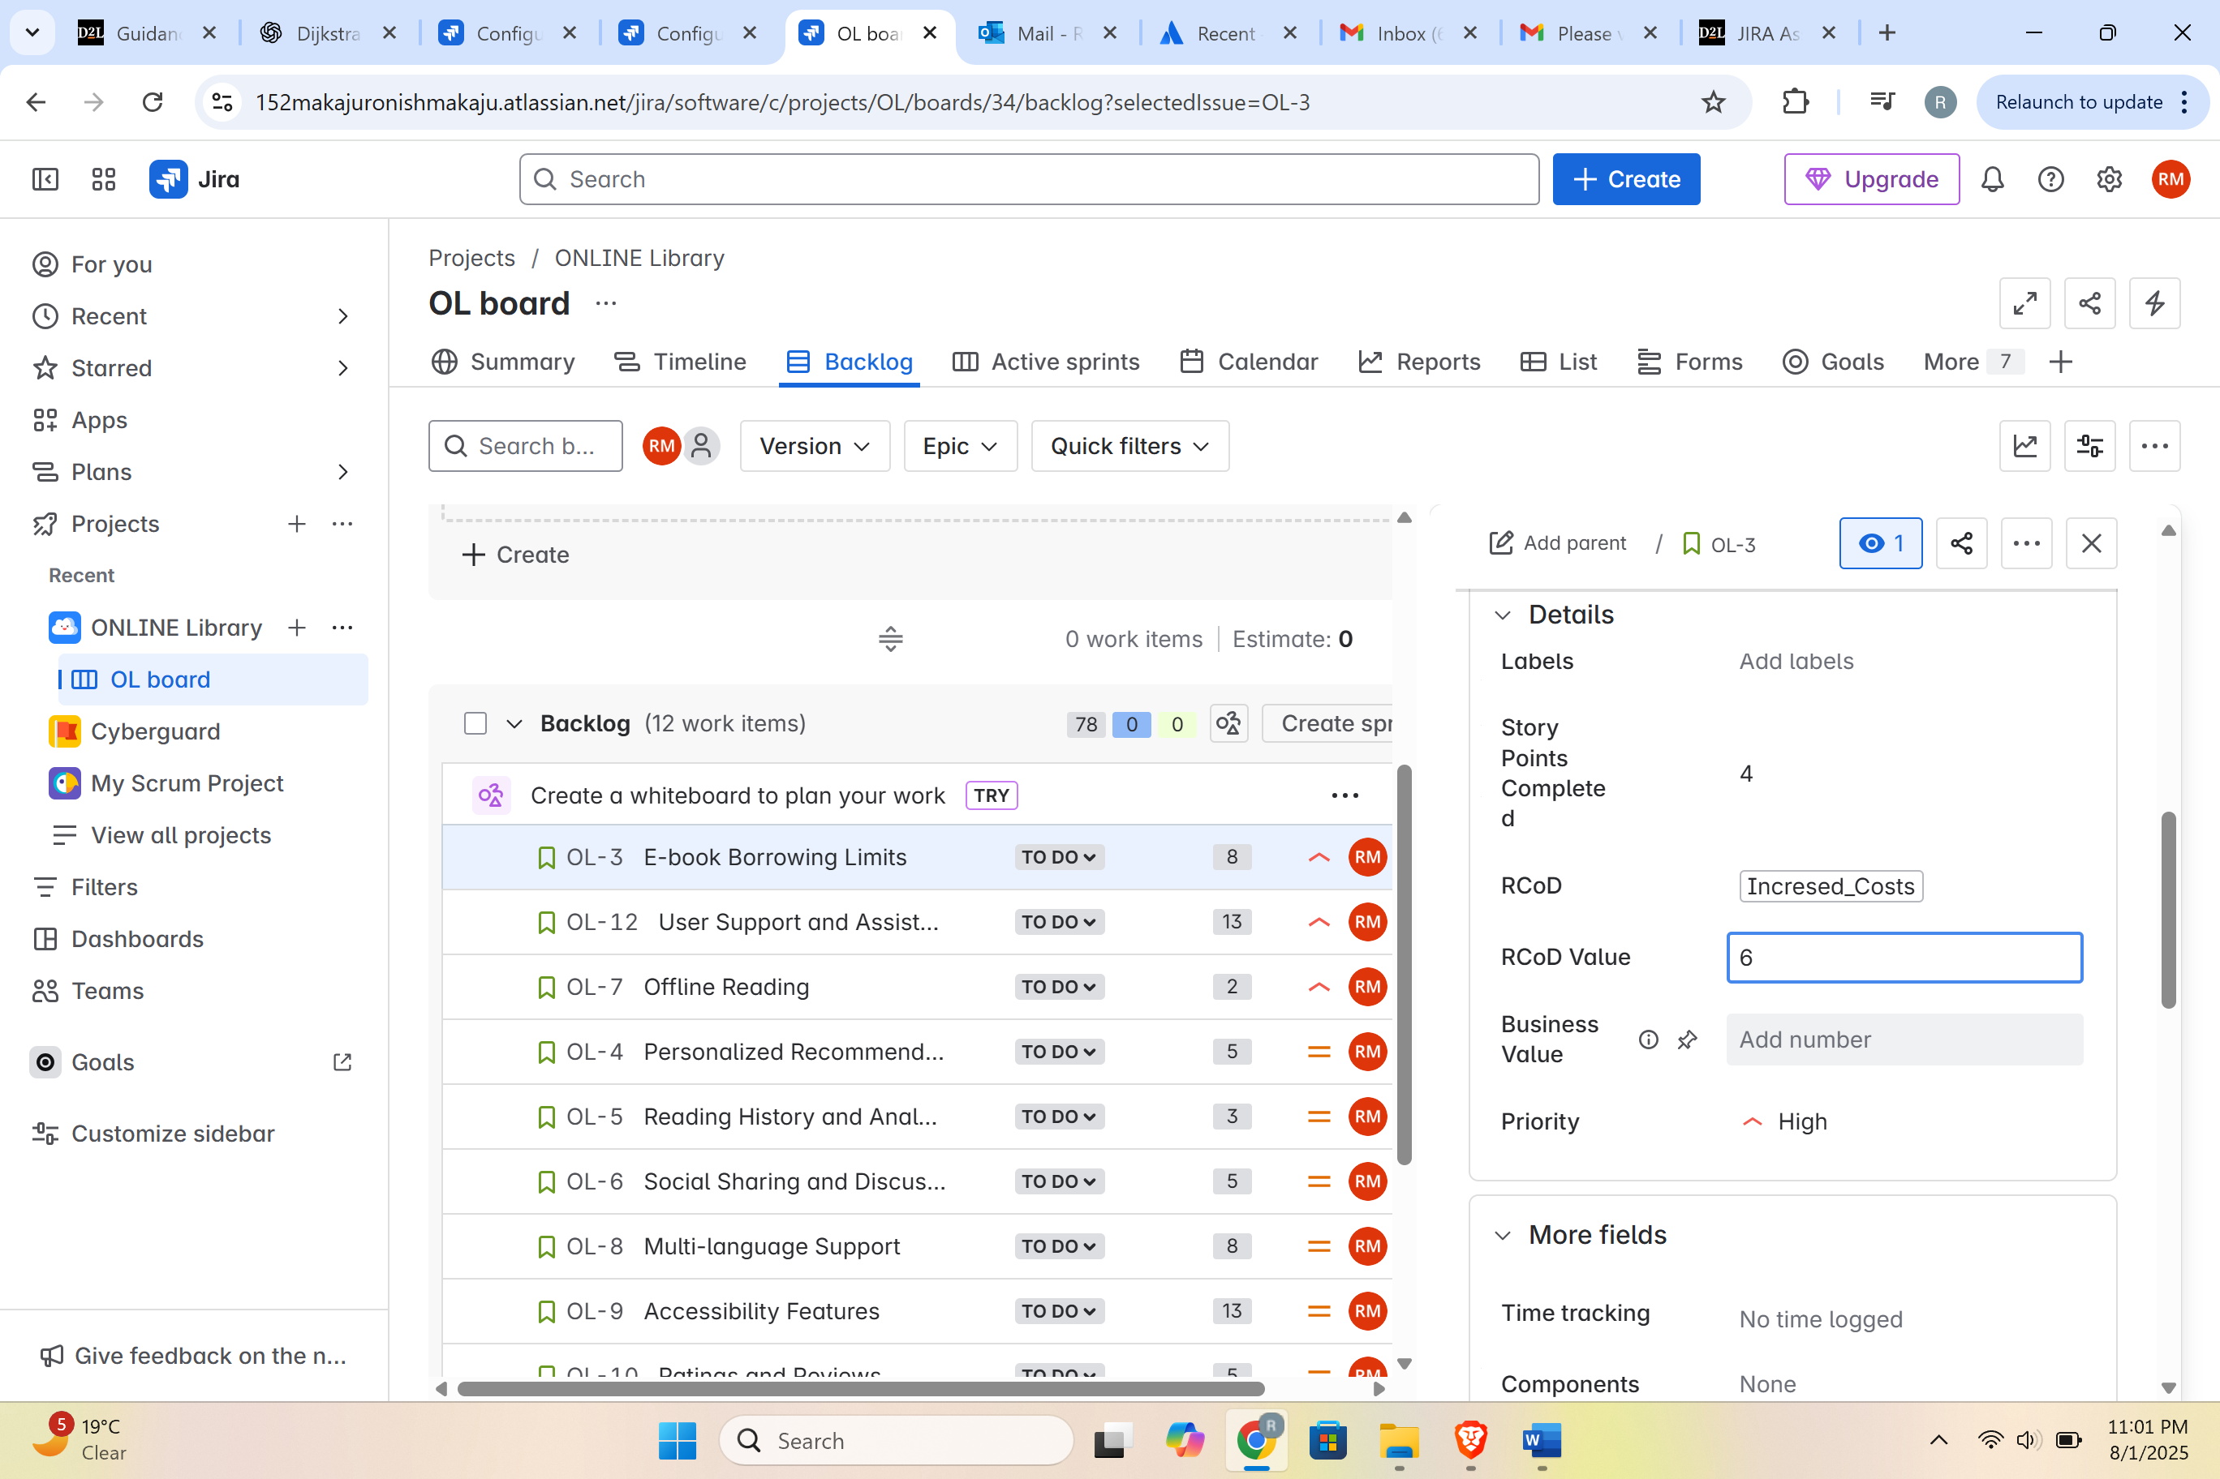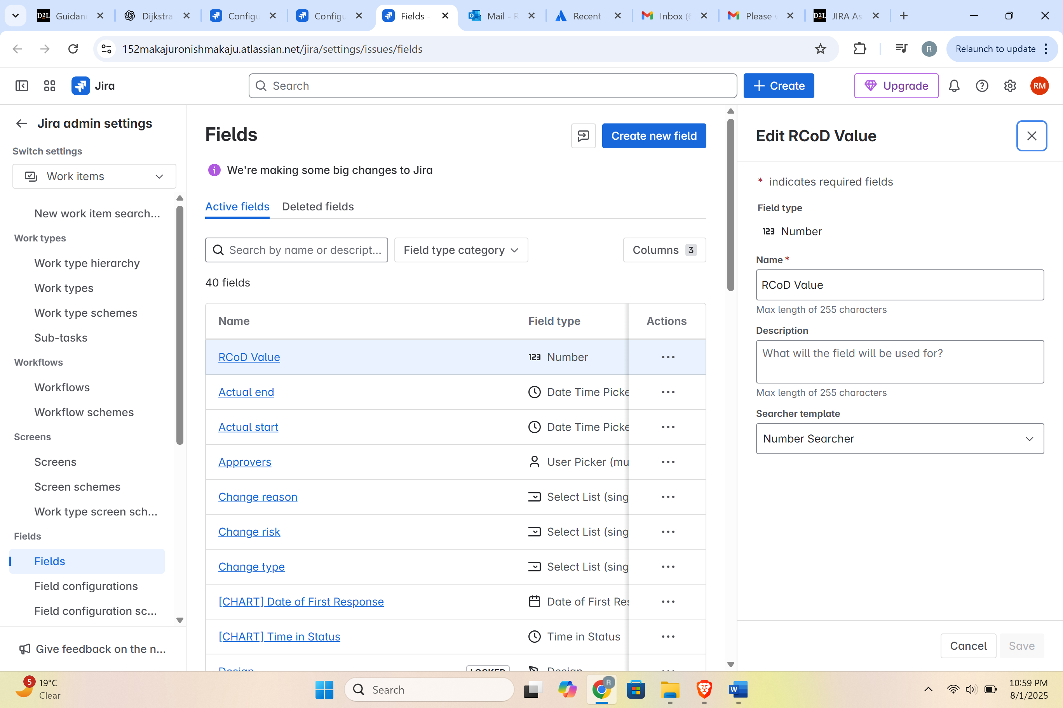

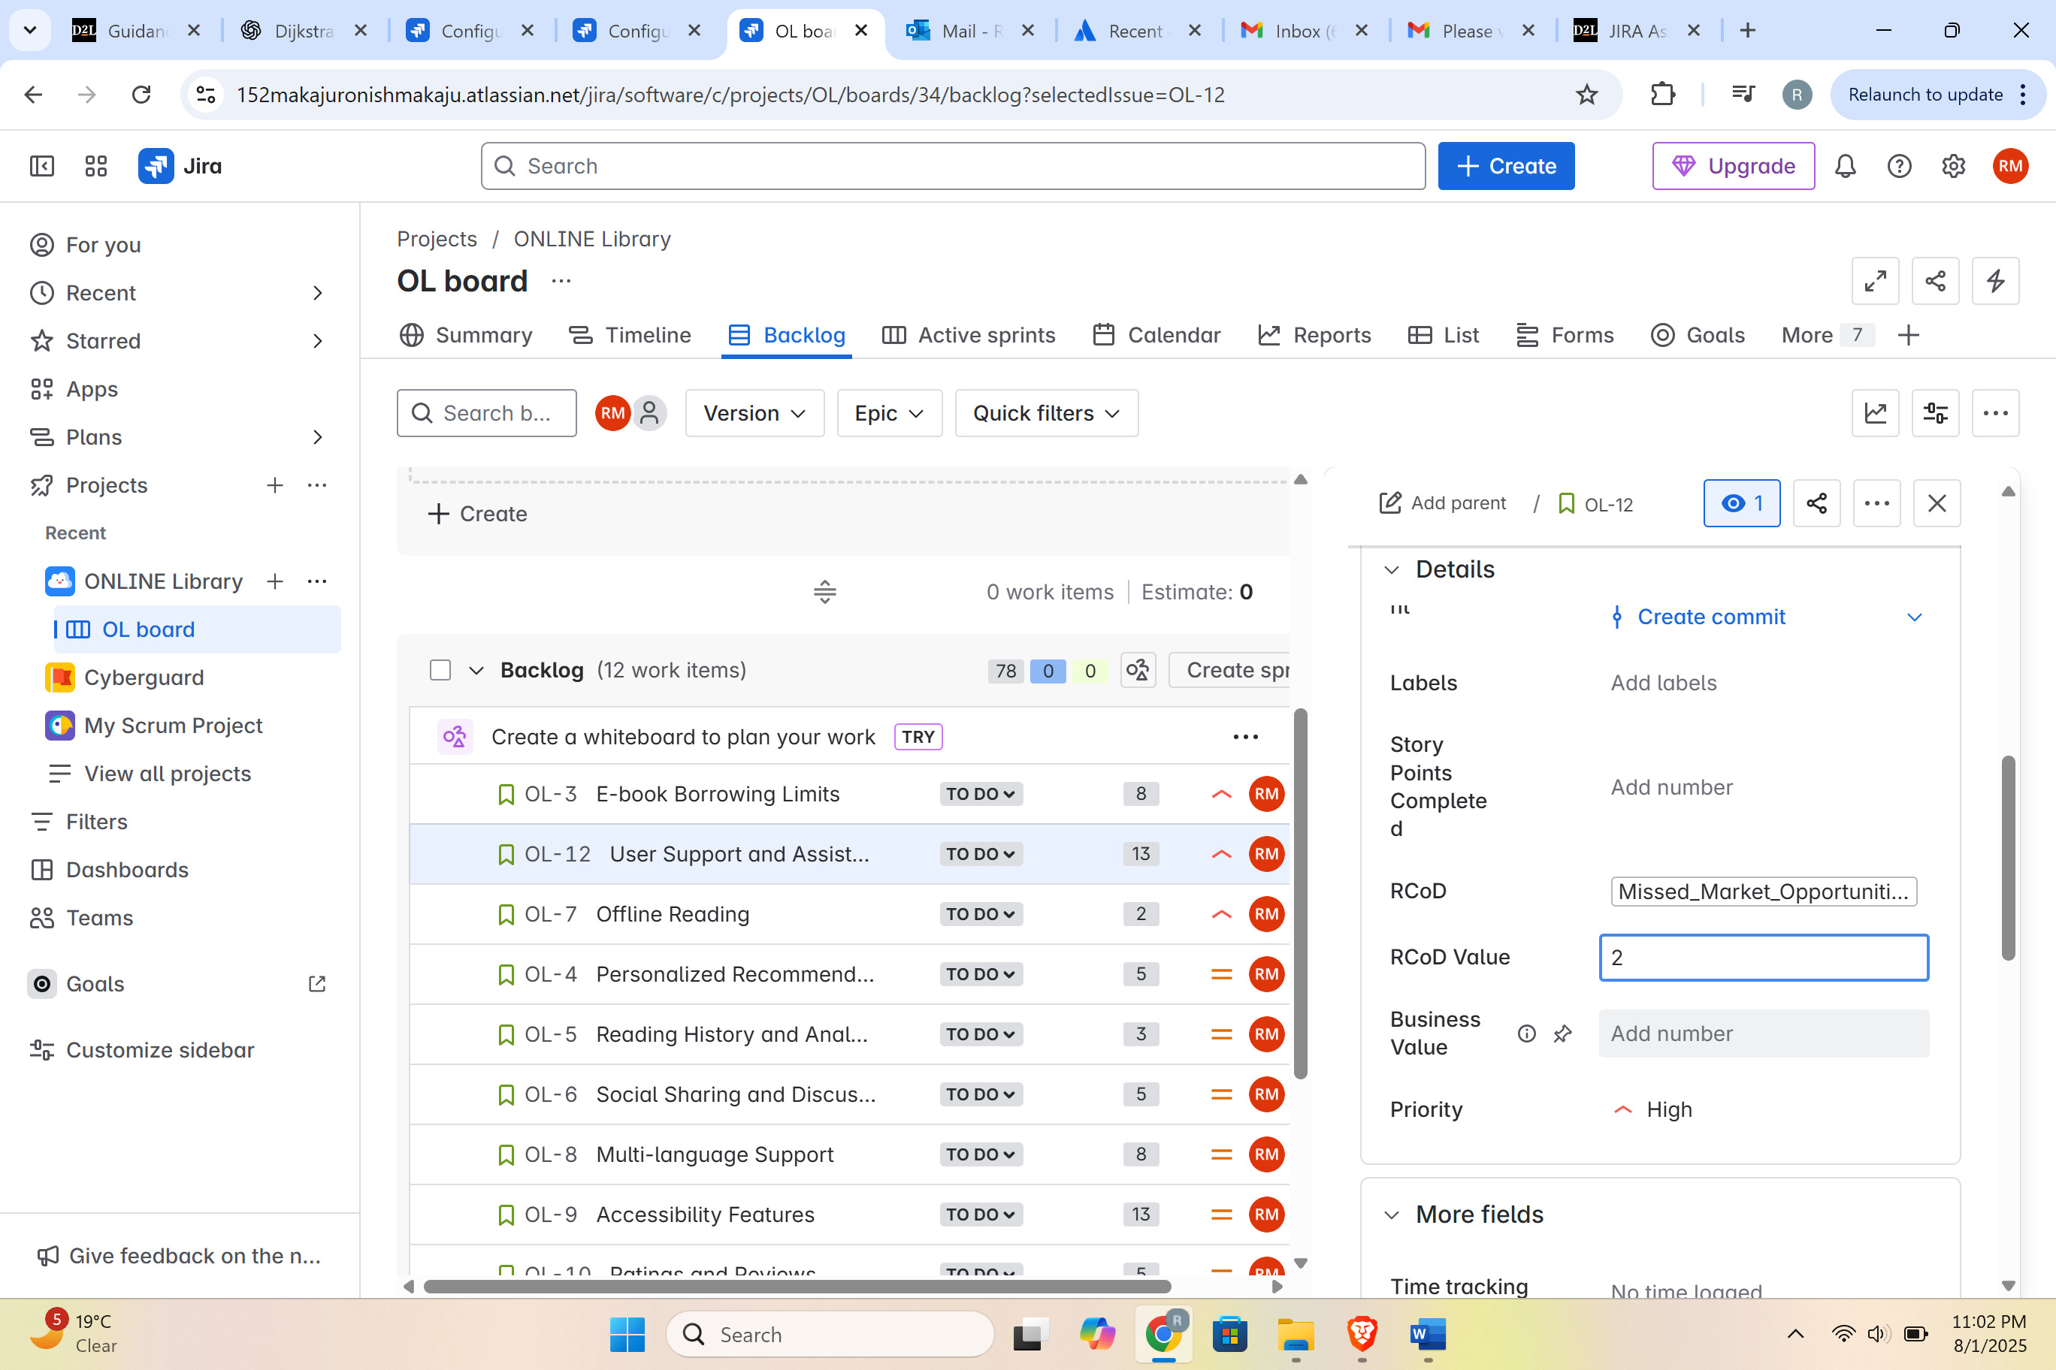

Filters  
